Docker Challenge

1.Create a customized Docker image using a Dockerfile.
Step 1: Create a project directory
Create a directory and change to that directory

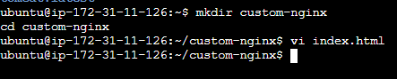

Also using vi add an html file

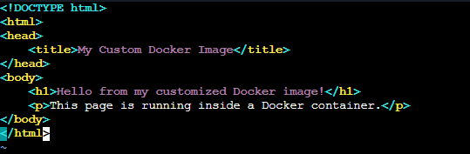
Step 2: Create the Dockerfile

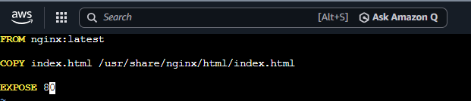

Step 4: Build the customized image

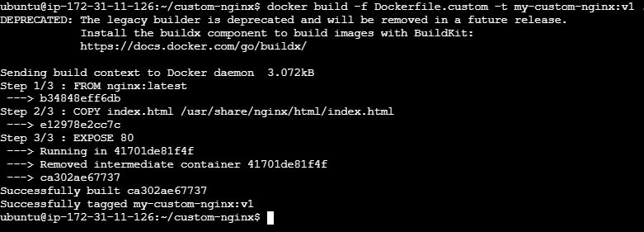

Step 5: Verify the image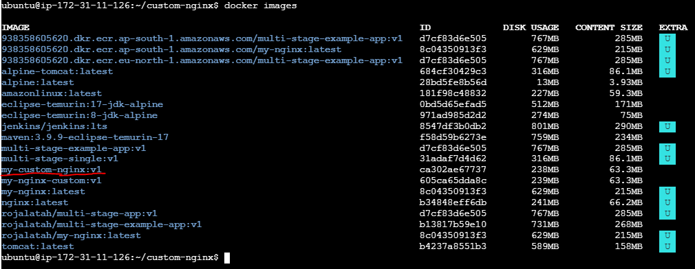

Step 6: Run the container

Step 7: Test it
From your browser: http://<EC2-PUBLIC-IP>:8085
Make sure your EC2 Security Group allows inbound TCP 8080.
You should see:
Hello from my customized Docker image!
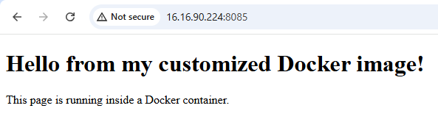

2. Push the image to Docker Hub.

Step 1: Log in to Docker Hub

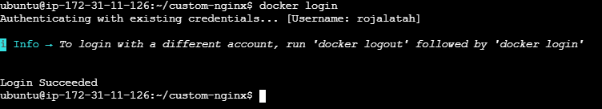

Step 2: Tag your image
Docker Hub expects the image name in this format: <username>/<repository>:<tag>
Step 3: Push the image
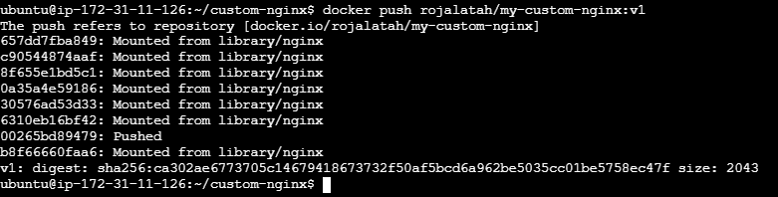

Step 4: Verify on Docker Hub

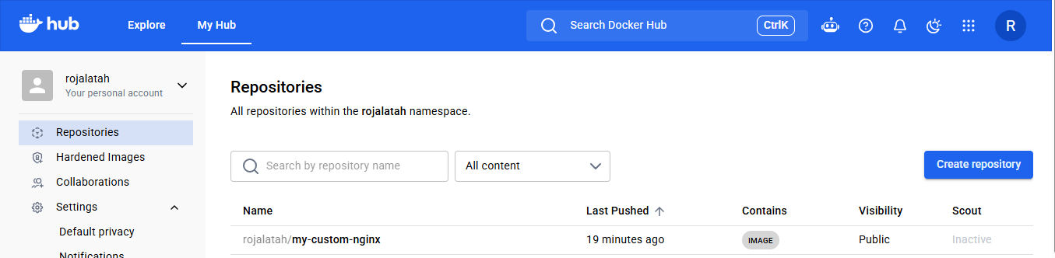
3. Push the same image to Amazon ECR.
Step 1: Create an ECR repository
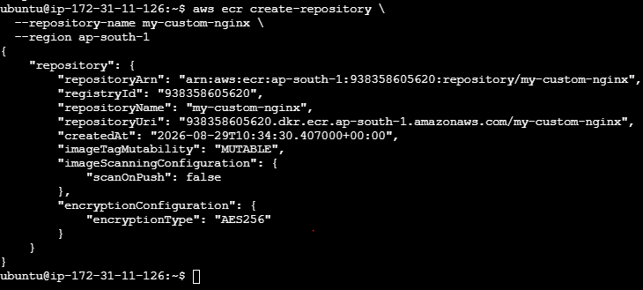

Step 2: Log in Docker to Amazon ECR

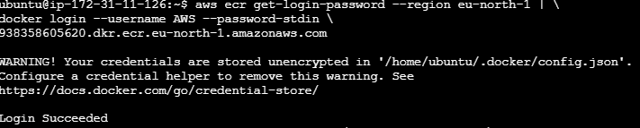
Step 3: Tag the same image for ECR

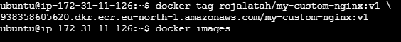

Step 4: Push your existing image

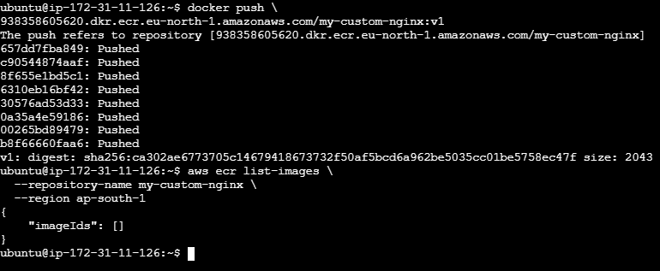

Verify the docker images

Step 5: Verify the image

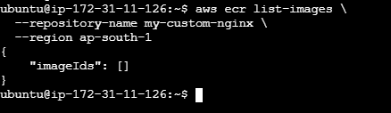
AWS Console → ECR → Repositories → my-custom-nginx

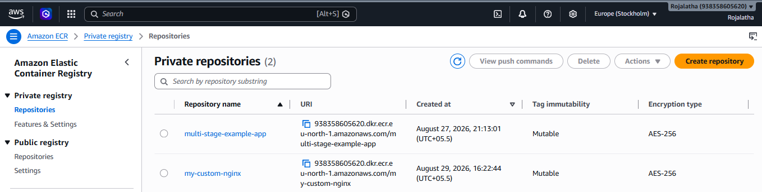
4. Provision one EC2 instance using Terraform and install Jenkins.

Step 1: Install Terraform
1. Update packages
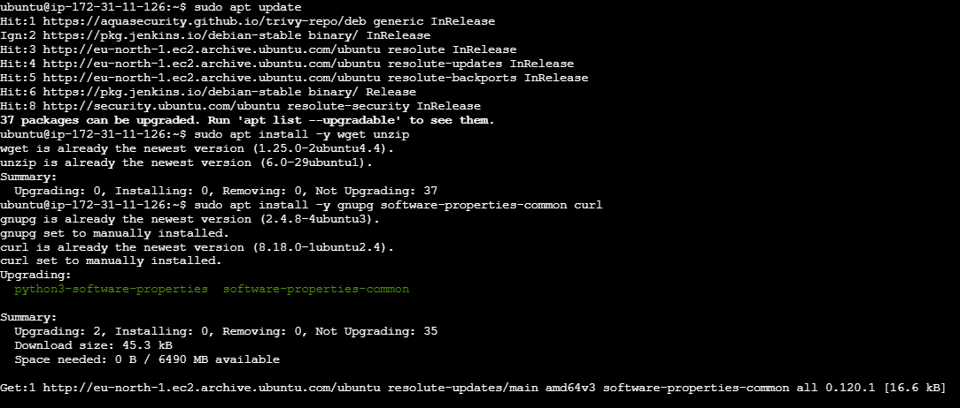

2. Install required packages

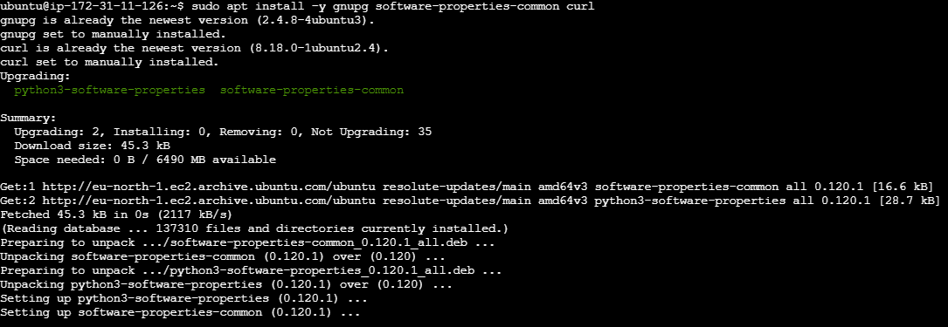

3. Add HashiCorp GPG key
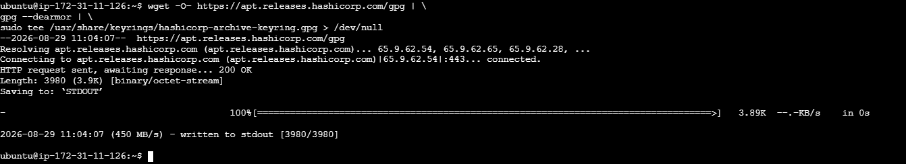

4. Add the Terraform repository

5. Install Terraform

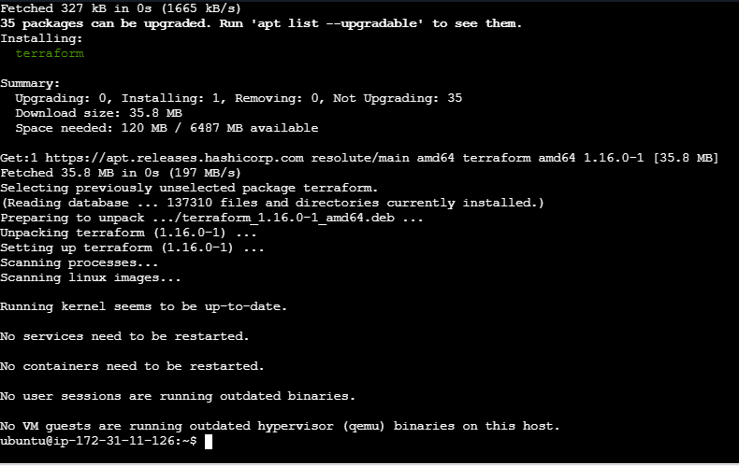
6. Verified Terraform version
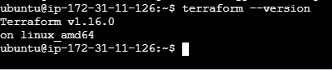

Step 2: Create a Terraform project
Create the Terraform file: Using vi main.tf
Change key_name to your actual key name
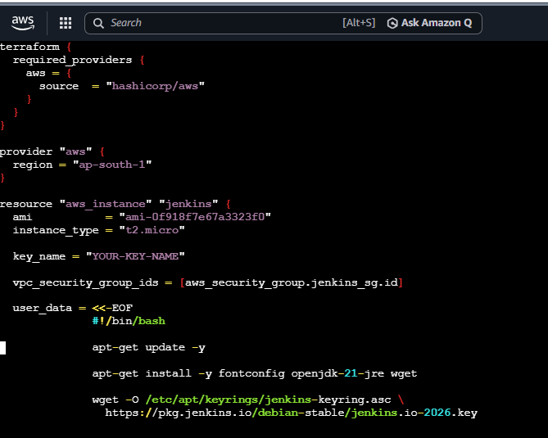 7827bf82ce744860acd516027c969636
Step 3: Configure AWS credentials
Make sure your AWS CLI is configured.
Initialize Terraform.
Check the configuration.
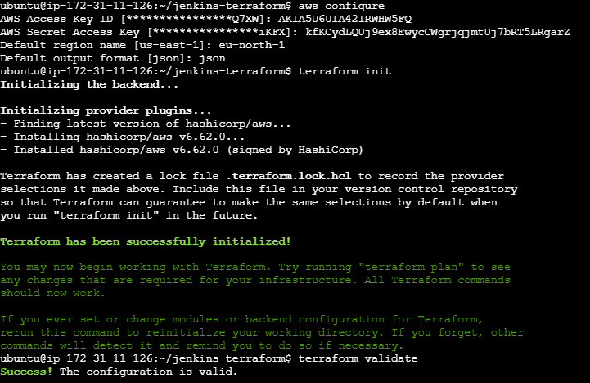

Step 6: See what Terraform will create
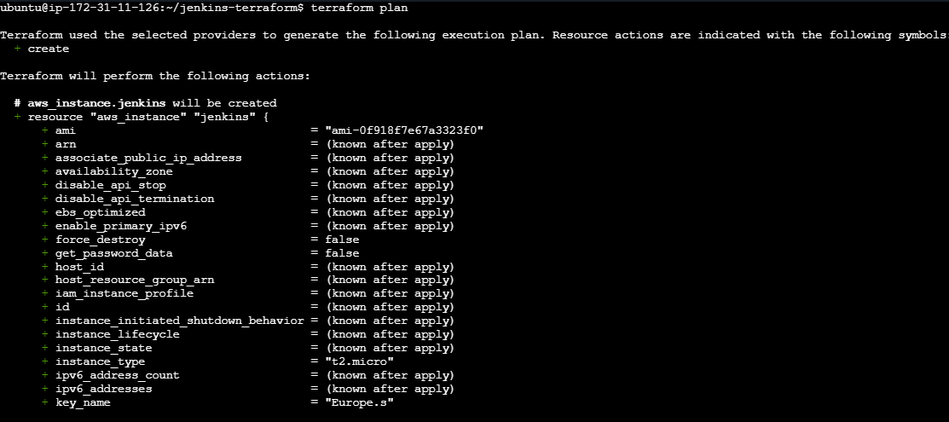

Step 7: Create the EC2 instance
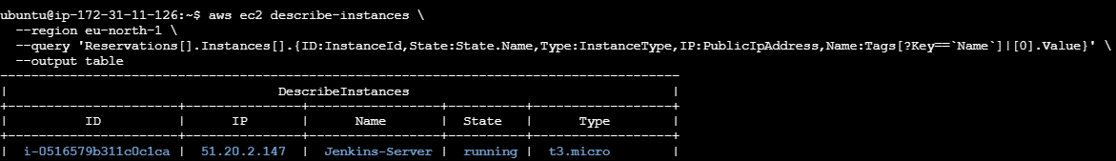
Access it on browser:
Cat initial password and paste it in Jenkins GUI
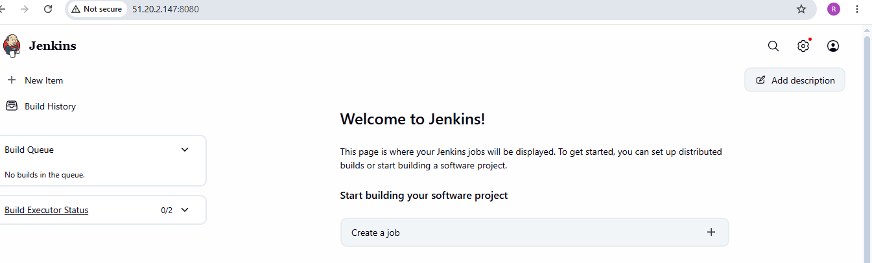
5. Create one Jenkins job to build and push the Docker image to Docker Hub.
  - Source:https://github.com/betawins/Python-app.git
Source Codes: https://github.com/betawins/docker-tasks.git
- From the frontend source code, write a Dockerfile, build a Docker image, run it, and push that image to your Docker registry.
- From the Java-based source code, write a Dockerfile, build, run, and push the image to the Docker registry.
- From the Node.js-based source code, write a Dockerfile, build with tagv1, run, and push it to the Docker registry.
- Write a docker-compose file to set up WordPress with a MySQL database.

Part 1 — Jenkins job to build and push Docker image
Step 1: Check your Jenkins server
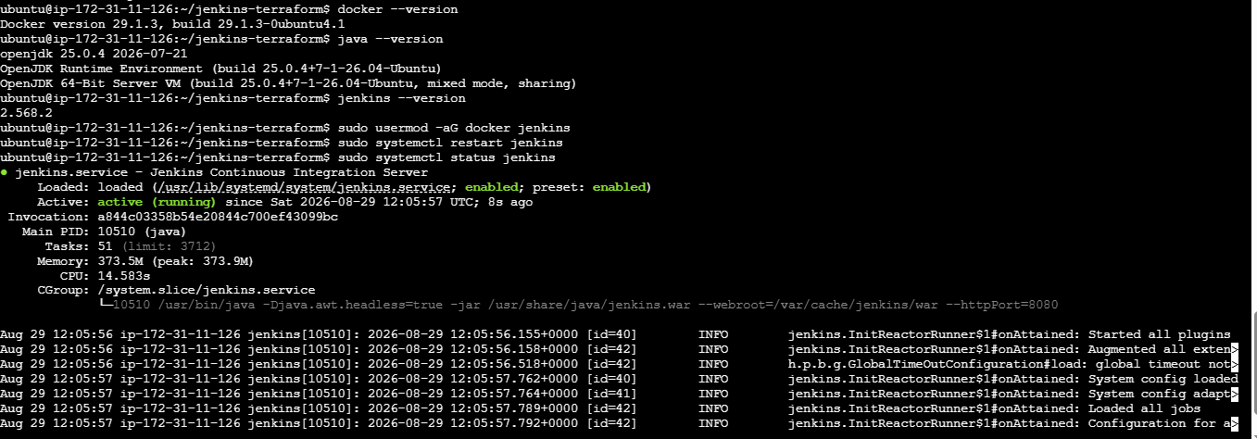
Step 2 — Get the Python application
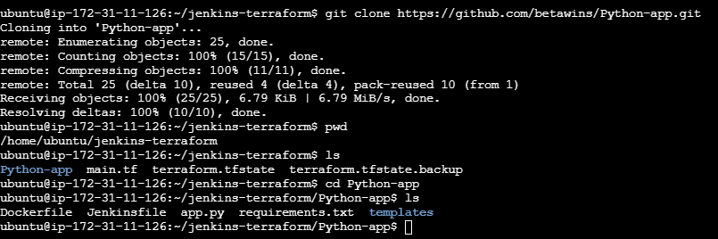
Step 3 — Create the Dockerfile
Using vi Dockerfile
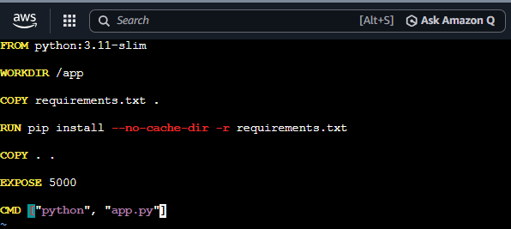
Build it manually to confirm:
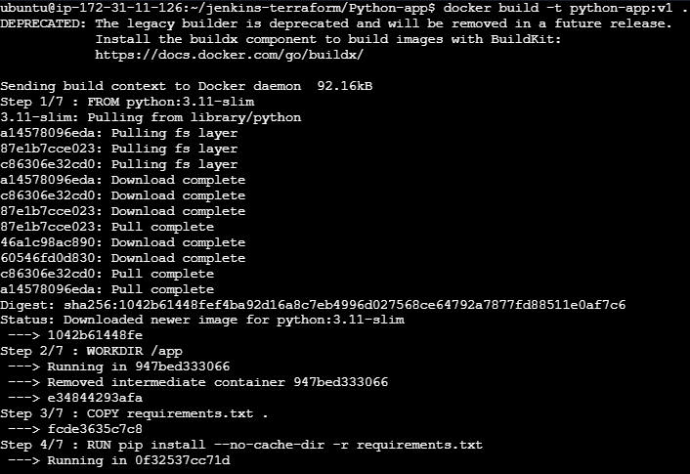
Check the docker images to see if image is build and then check the running containers
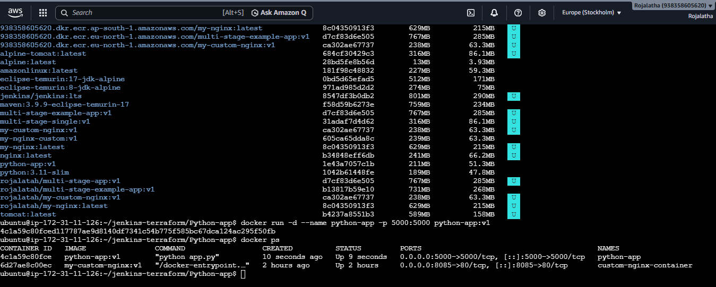

Part 2 — Push the image to Docker Hub
Tag the image
Login to docker
Now push the image to Dockerhub

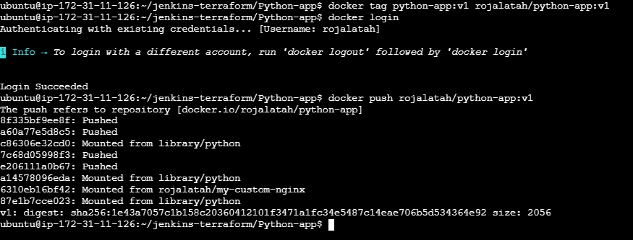

Part 3 — Automate this with Jenkins
Go to Jenkins → New Item → Pipeline
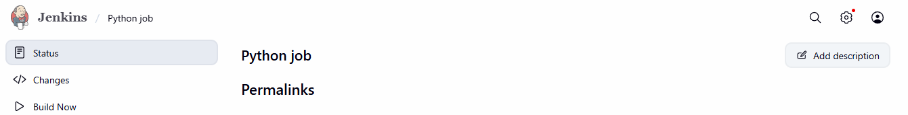

Step 4 — Add Docker Hub credentials
Go to Jenkins → Manage Jenkins → Credentials → Global → Add Credentials
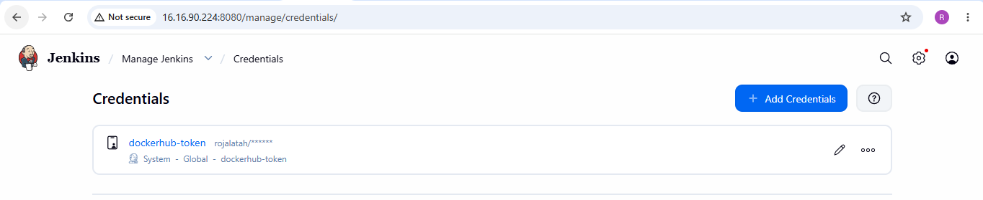
Step 5 — Jenkins Pipeline
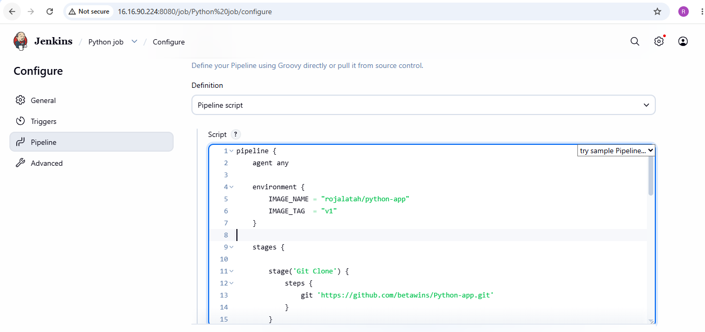

Job is executed successfully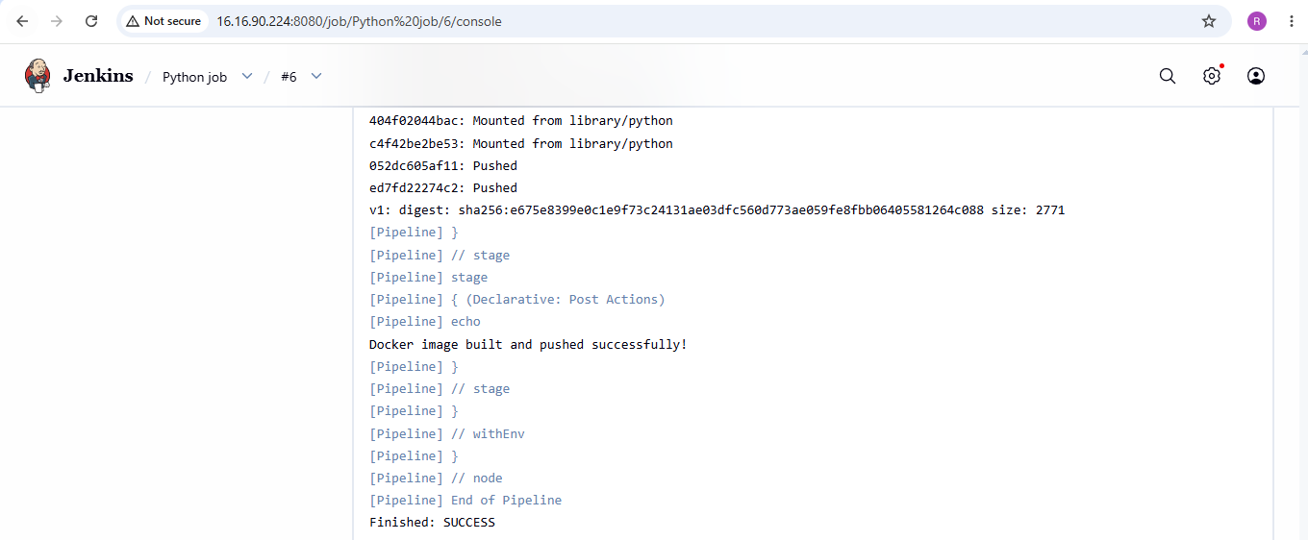

Part 4 — Frontend source code
The frontend source appears to be in the docker-tasks repository:
https://github.com/betawins/docker-tasks.git
Clone it:
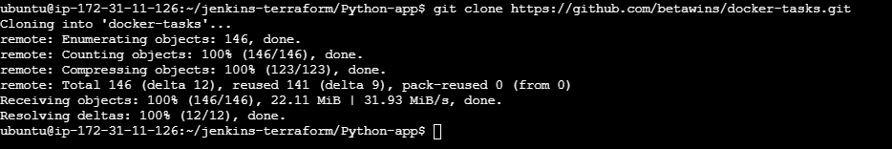
Change to docker-tasks and inspect it:
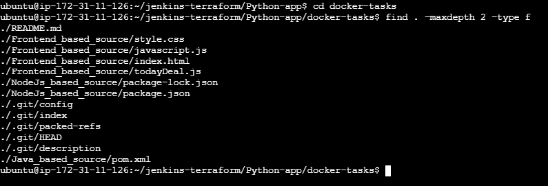
Now build the container, run it, tag and push the container

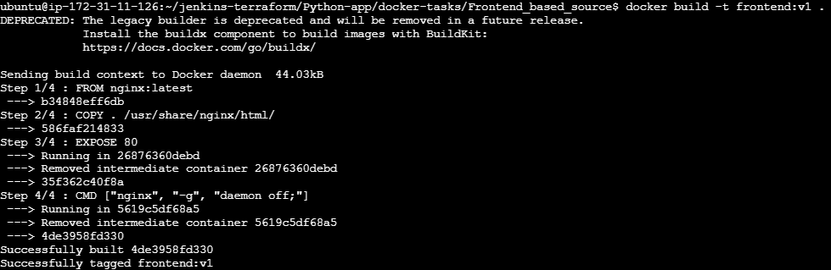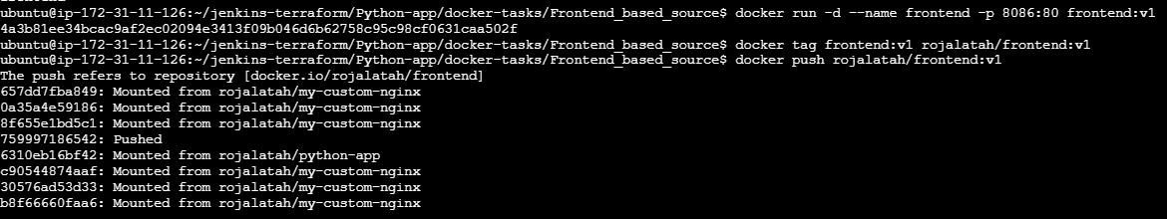
Part 5 — Java-based source code
For a Java application, first identify whether it uses Maven.
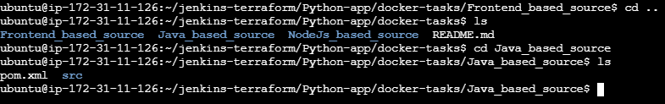
Now build the application
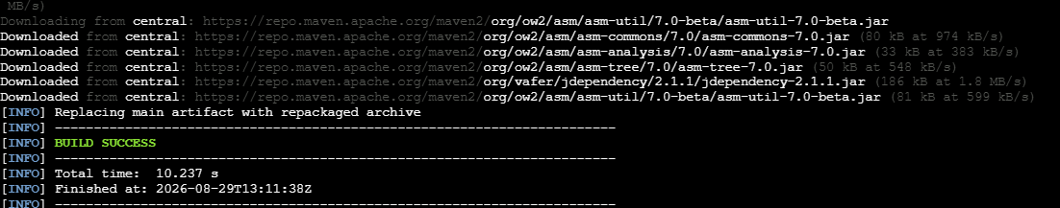

Now create a docker file using vi
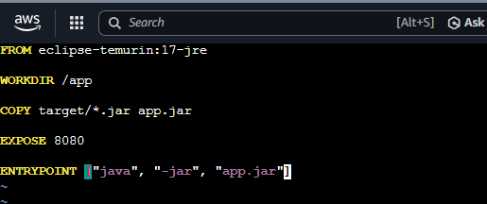

Build the image, run and tag, then push the image:
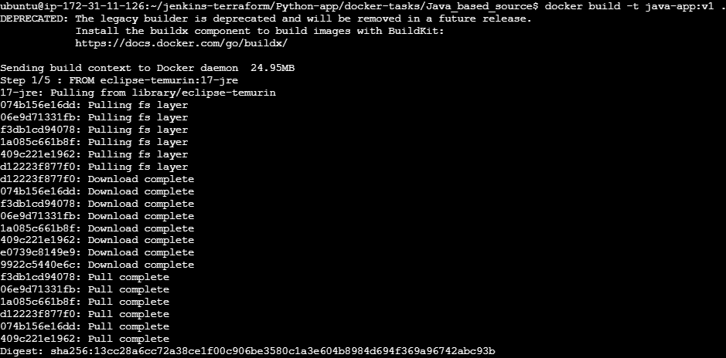

Part 6— Node.js Docker image

Step 1: Go to the Docker tasks repository
On your Ubuntu server:
Go to Directory Docker tasks and enter NodeJs_based_source
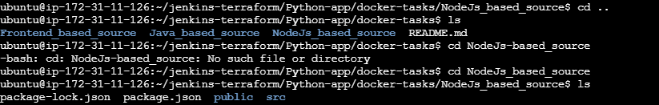

Step 2: Create the Node.js Dockerfile
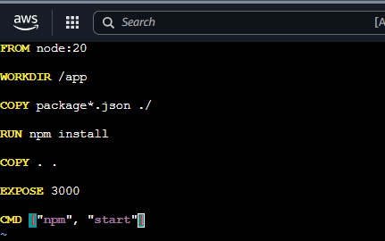

Step 3: Build the image with v1
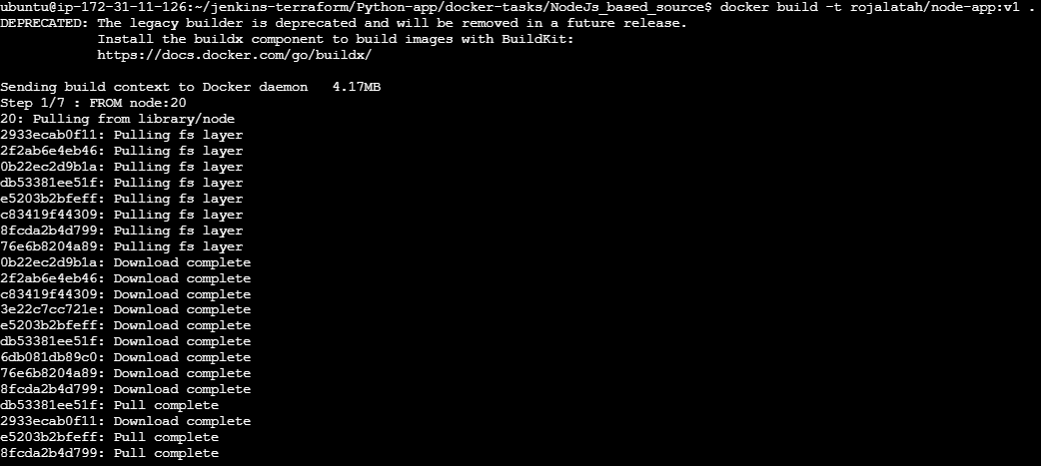

Verify Docker images:

Step 4: Run the Node.js container and check running containers

Step 5: Test the application
From your computer's browser: http://<EC2-PUBLIC-IP>:8088


Step 6: Login to Docker Hub
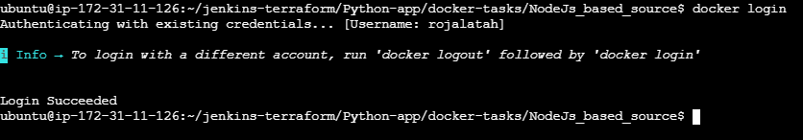

Then push the image to dockerhub:
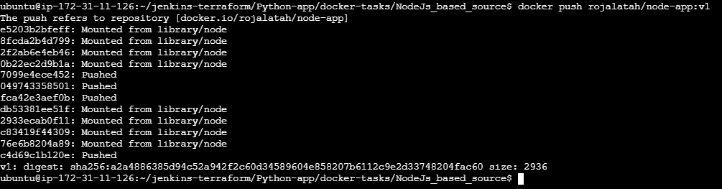

Verify it in dockerhub:
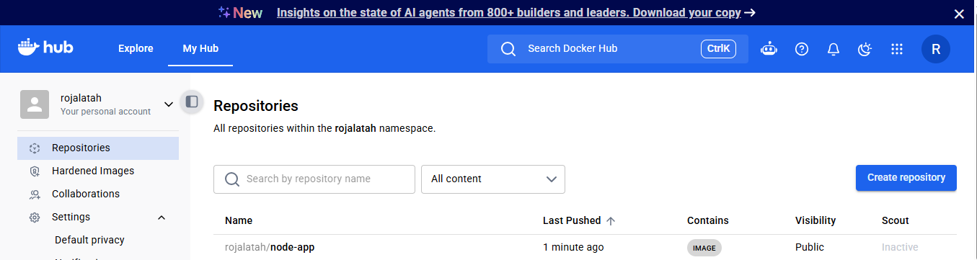

Part 7 — WordPress + MySQL using Docker Compose
Now create a separate directory:
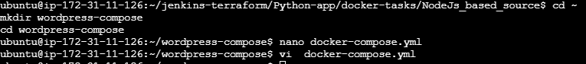

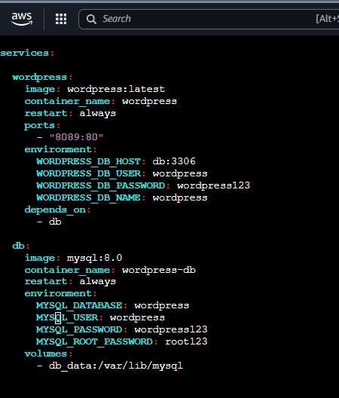

Step 7: Start WordPress and MySQL
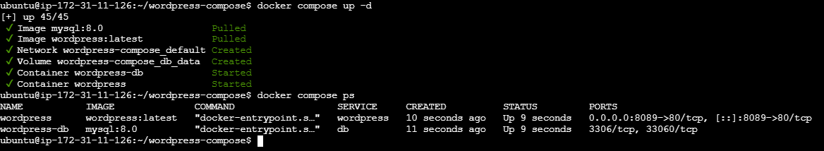
Then open: http://<EC2-PUBLIC-IP>:8089
You should get the WordPress installation page.
